**EXERCISE:**



1)

2)

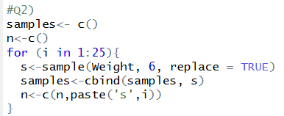

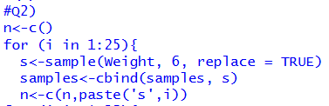





3)



